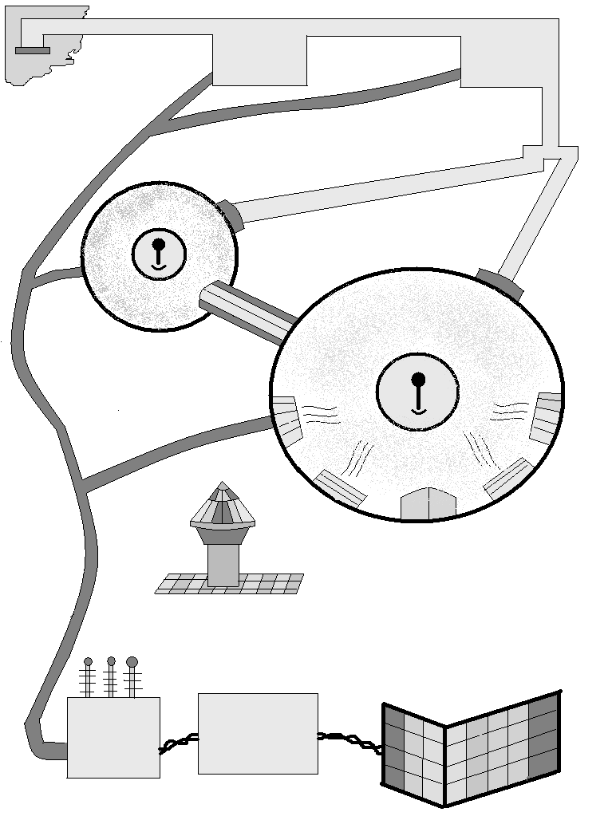
Design of the Moon base
Ice crystal extractor and melting area
Ice cap
Water purifier and distributor
Impure water
Ice crystals
Wires

Pure water
Water pipes
To greenhouse plant
To base
Greenhouse plant
Dome shaped base
Antenna
Air cooler
Heater
Oxygen and carbon dioxide interchanges
Probe launching area (Probes will be required for radio transmission and communication
Electricity distribution and storage area
Solar power to electricity converter
High- power Solar cells
Electricity
Location: Near a lunar ice cap
Source of enegy: Solar energy harnessed through solar cells
Temperature maintenance: Through super heaters and coolers
Air supplier: Green house plant
Communication: Through radar- communicators ( the probe launced by the probe launcher will transmit the radar signals and provide the weather reports.
Food supply: From the green house plant
Water supply: The ice crystals collected from the ice-cap will be boiled, purified and distilled to provide pure water.

By;
Shoumik Goswami
Class: IX
Age: 14
Location: Guwahati,
Assam, India.

